WEEK – 4
TASK 4.1: DETERMINE-IF-STRING-HALVES-ARE-LIKE PROGRAM:
class Solution {
public boolean halvesAreAlike(String s) { int mid = s.length() / 2;
long first = s.substring(0, mid)
.chars()
.filter(c -> "aeiouAEIOU".indexOf(c) != -1)
.count();

long second = s.substring(mid)
.chars()
.filter(c -> "aeiouAEIOU".indexOf(c) != -1)
.count();

return first == second;
}
}

OUTPUT:
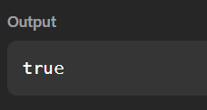

TASK 4.2 : LAPIN PROGRAM:
import java.util.*; class Main {
public static void main(String[] args) { Scanner sc = new Scanner(System.in); int T = sc.nextInt();
while (T-- > 0) { String s = sc.next(); int n = s.length(); int mid = n / 2;
int[] first = new int[26]; int[] second = new int[26]; for (int i = 0; i < mid; i++) {
first[s.charAt(i) - 'a']++;
}
for (int i = (n + 1) / 2; i < n; i++) { second[s.charAt(i) - 'a']++;
}
if (Arrays.equals(first, second)) { System.out.println("YES");
} else {
System.out.println("NO");
}
}
sc.close();
}
}

OUTPUT:
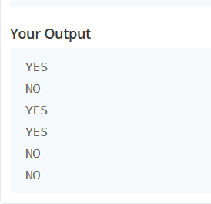

TASK 4.3 : COMPARE THE TRIPLETS PROGRAM:
import java.util.*; class Result {
public static List<Integer> compareTriplets(List<Integer> a, List<Integer> b) { int aliceScore = 0;
int bobScore = 0;
for (int i = 0; i < 3; i++) { if (a.get(i) > b.get(i)) {
aliceScore++;
}
else if (a.get(i) < b.get(i)) { bobScore++;
}
}
return Arrays.asList(aliceScore, bobScore);
}
}
public class Solution {
public static void main(String[] args) { Scanner sc = new Scanner(System.in); List<Integer> a = new ArrayList<>(); List<Integer> b = new ArrayList<>(); for (int i = 0; i < 3; i++) {
a.add(sc.nextInt());
}
for (int i = 0; i < 3; i++) { b.add(sc.nextInt());
}

List<Integer> result = Result.compareTriplets(a, b); for (int score : result) {
System.out.print(score + " ");
}
sc.close();
}
}

OUTPUT:


TASK 4.4 : CONTAINS DUPLICATES PROGRAM:
class Solution {
public boolean containsDuplicate(int[] nums) { HashSet<Integer> set = new HashSet<>(); for (int n : nums) {
if(set.contains(n)) { return true;
}
set.add(n);
}
return false;
}
}

OUTPUT:
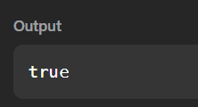

TASK 4.5 : TIME CONVERSION PROGRAM:
import java.io.*; import java.util.*; class Result {
public static String timeConversion(String s) { String period = s.substring(8, 10);
int hour = Integer.parseInt(s.substring(0, 2)); if (period.equals("AM")) {
if (hour == 12) { hour = 0;
}
}
else {
if (hour != 12) { hour = hour + 12;
}
}
return String.format("%02d", hour) + s.substring(2, 8);
}
}
public class Solution {
public static void main(String[] args) throws IOException { BufferedReader bufferedReader =
new BufferedReader(new InputStreamReader(System.in)); BufferedWriter bufferedWriter =
new BufferedWriter(new FileWriter(System.getenv("OUTPUT_PATH"))); String s = bufferedReader.readLine();
String result = Result.timeConversion(s);

bufferedWriter.write(result); bufferedWriter.newLine(); bufferedReader.close(); bufferedWriter.close();
}
}

OUTPUT:
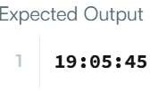

TASK 4.6 :MOVE ZEROES

PROGRAM:

class Solution {
public void moveZeroes(int[] nums) {

int j = 0;

for (int i = 0; i < nums.length; i++) {

if (nums[i] != 0) {
int temp = nums[i];
nums[i] = nums[j];
nums[j] = temp;

j++;
}
}
}
}

OUTPUT:

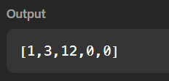

TASK 4.7:DIAGONAL DIFFERENCE
PROGRAM:

import java.util.*;

public class Solution {

public static int diagonalDifference(List<List<Integer>> arr) {
int n = arr.size();
int leftDiagonal = 0;
int rightDiagonal = 0;

for (int i = 0; i < n; i++) {
leftDiagonal += arr.get(i).get(i);
rightDiagonal += arr.get(i).get(n - 1 - i);
}

return Math.abs(leftDiagonal - rightDiagonal);
}
}

OUTPUT:

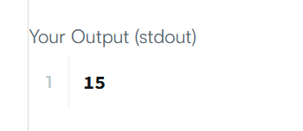

TASK 4.8: TRANSPOSE MATRIX

PROGRAM:

import java.util.stream.IntStream;

class Solution {
public int[][] transpose(int[][] matrix) {
int rows = matrix.length;
int cols = matrix[0].length;

return IntStream.range(0, cols)
.mapToObj(j ->
IntStream.range(0,rows)
.map(i -> matrix[i][j])
.toArray()
)
.toArray(int[][]::new);
}
}

OUTPUT:
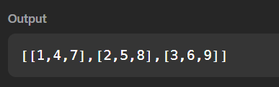

TASK 4.9:MATRIX BLOCK SUM

PROGRAM:

class Solution {
public int[][] matrixBlockSum(int[][] mat, int k) {

int m = mat.length;
int n = mat[0].length;

int[][] answer = new int[m][n];

for (int i = 0; i < m; i++) {
for (int j = 0; j < n; j++) {

int sum = 0;

for (int r = Math.max(0, i - k);
r <= Math.min(m - 1, i + k);
r++) {

for (int c = Math.max(0, j - k);
c <= Math.min(n - 1, j + k);
c++) {

sum += mat[r][c];
}
}

answer[i][j] = sum;
}
}

return answer;
}
}

OUTPUT:

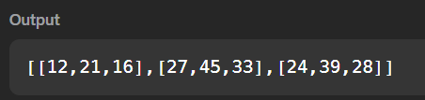

TASK 4.10: MATRIX ROTATION

PROGRAM:

import java.io.*;
import java.util.*;

public class Solution {

public static void matrixRotation(List<List<Integer>> matrix, int r) {

int rows = matrix.size();
int cols = matrix.get(0).size();

int[][] result = new int[rows][cols];

for (int layer = 0; layer < Math.min(rows, cols) / 2; layer++) {

List<Integer> elements = new ArrayList<>();

for (int j = layer; j < cols - layer; j++) {
elements.add(matrix.get(layer).get(j));
}

for (int i = layer + 1; i < rows - layer; i++) {
elements.add(matrix.get(i).get(cols - layer - 1));
}
for (int j = cols - layer - 2; j >= layer; j--) {
elements.add(matrix.get(rows - layer - 1).get(j));
}

for (int i = rows - layer - 2; i > layer; i--) {
elements.add(matrix.get(i).get(layer));
}

int size = elements.size();
int rotation = r % size;
int index = 0;
for (int j = layer; j < cols - layer; j++) {
result[layer][j] =
elements.get((index + rotation) % size);
index++;
}
for (int i = layer + 1; i < rows - layer; i++) {
result[i][cols - layer - 1] =
elements.get((index + rotation) % size);
index++;
}
for (int j = cols - layer - 2; j >= layer; j--) {
result[rows - layer - 1][j] =
elements.get((index + rotation) % size);
index++;
}

for (int i = rows - layer - 2; i > layer; i--) {
result[i][layer] =
elements.get((index + rotation) % size);
index++;
}
}

for (int i = 0; i < rows; i++) {
for (int j = 0; j < cols; j++) {
System.out.print(result[i][j]);

if (j < cols - 1) {
System.out.print(" ");
}
}
System.out.println();
}
}

public static void main(String[] args) throws IOException {

BufferedReader br =
new BufferedReader(new InputStreamReader(System.in));

String[] firstLine = br.readLine().trim().split(" ");

int rows = Integer.parseInt(firstLine[0]);
int cols = Integer.parseInt(firstLine[1]);
int r = Integer.parseInt(firstLine[2]);

List<List<Integer>> matrix = new ArrayList<>();

for (int i = 0; i < rows; i++) {

String[] values = br.readLine().trim().split(" ");

List<Integer> row = new ArrayList<>();

for (String value : values) {
row.add(Integer.parseInt(value));
}

matrix.add(row);
}

matrixRotation(matrix, r);
}
}

OUTPUT:

